67

Casierra-Posada y Gonzalez - Cambio Circadino de PH en la Savia de Fique Volumen 13 - No 1 - Año 2009



BIOTECNOLOGÍA

Revista ORINOQUIA - Universidad de los Llanos - Villavicencio, Meta. Colombia Volumen 13 - No 1 - Año 2009

68

Artículo de Opinión /Opinión Article


Biotechnology, beginning with recombinant
DNA toward a personalized medicine

Noel Verjan García

Specially Appointed Researcher, Laboratory of Immunodynamics,WPI Immunology Frontier Research
Center, Osaka University, 2-2, Yamada-oka, Suita 565-0871, Japan, tel: +81-6-6879-3996 fax:+81-6-6879-3979,E-mail: verjangn@orgctl.med.osaka-u.ac.jp

I would like to initiate this document by making a brief description of the term Biotechnology, hoping to not hurt the feelings of many other professionals better versed than I, on the details of this science, as the application of traditional and/or scientific knowledge to manipulate microorganisms, cells or even higher organ- isms, directed to supply goods and services to the daily growing human population. With almost 30-year-old, biotechnology, driven by the ability to transplant a gene from one organism into another to introduce novel func- tionality in the receiving organism, has evolved to repro- gram cellular behavior or incorporate increasingly com- plex biosynthetic pathways (to produce novel metabolic products or to achieve greater system integration) or genetic regulatory constructs (to modulate the activity of recombinant genes in space and time) (Bhalerao,
Casierra-Posada y Gonzalez - Cambio Circadino de PH en la Savia de Fique Volumen 13 - No 1 - Año 2009
2009). Biotechnology one of the riskiest industries has achieved a dynamic growth and unparalleled discovery, outstanding advances and contributions to human and animal medicine. This has mainly been possible throughout the exploration of diverse unicellular and multicellular genomes, the genes and the proteins they encode, and together with the development of dozens of technologies, reach every day a better understand- ing of cell biology, homeostasis and disease. Thus, biotechnology has established as an industry, where any bio-product can be patentable. Among the great-
est technological advances that have fueled biotech- nology research into a wide range of interesting areas that might have lead to new therapeutics and diagnos- tics are gene amplification (PCR) and protein engineer- ing technologies, rapid genetic sequencing, automated liquid handling, protein analysis (Gas chromatography- mass spectroscopy, GCMS, Liquid chromatography- mass spectrometry, LCMS), plant and animal cell cul- ture, real-time cell analysis, sample-preparation meth- ods, fermentation technology, monoclonal antibody technology, microarrays and very important, high-speed computing (De Palma, 2005). The most successful uses of biotechnology so far have been the production of therapeutic drugs (biologics); genetically modified (GM) plants; and medical diagnostic tools such as DNA testing. Of note, developed countries own the indus- try, with an estimate of about 1,283 biotechnology com- panies only in the United States that employ more than
150,000 people in high value jobs, a record of seven- fold increase in the invested money from 45 billion USD in 1994 to 330 billion USD in 2001, and an increased rate in the number of issued patents. To mention, the number of patents issued per year increased almost 9- fold, from 518 patents in 1981 to 4,561 patents in 2001, and from 25 patents per year issued in the early 1990s to U.S universities, sharply rose to 174 in 1999 (Taylor and Cayford, 2003).

Diseases have been since them recognition, the main source of mortality in humans and animal spe- cies, particularly those subjected to intensive pro- duction. They not only originate from diverse alter- ations in the environment, including abundance of microbial and multicellular pathogens, and nutritional status of the host, but also by specific alterations in genes and the proteins they encodes, determin- ing a novel phenotype, in other words, mutation. Therefore, motivation of insurers to pay for new medical treatments drives the demand for biotech- nological products and services. Beginning with recombinant DNA in the late 1970’s and earliest
1980’s, a major biotechnology’s breakthrough lead to the cloning and expression of several recombi- nant proteins, with profound impact on research and life sciences. Of note, Genetech, Inc, reported the production of the first human protein manufactured in bacteria in 1977, and this lead to replacement treatments like insulin (Humulin) in the treatment of type I diabetes mellitus (Johnson, 1983). Erythro- poietin (Epogen) in anemia associated with chronic renal failure and patented by Amgen in 1989 (Eschbach et al., 1987; Lin et al., 1985), granulo- cyte-colony stimulating factor, G-CSF (Neupogen) in the treatment of neutropenia in cancer patients and hematopoietic stem cell transplantation to de- crease the incidence of infection associated with some forms of chemotherapy (Nagata et al., 1986; Souza et al., 1986), and the human growth hor- mone (Protropin) in the treatment of its direct defi- ciency or in syndromes accompanied with short- ness, wasting, obesity and renal transplantation (Gotherstrom et al., 2007). It is worth to mention the production of recombinant interferon (rIFN) with today’s more than ten products in the market place (among them are INFERGEN, AVONEX), rIFN has been widely used to treat cancer, autoimmune dis- orders included multiple sclerosis and viral infec- tions (Nagata et al., 1980; Takaoka et al., 2003).

These advancements have lead to a greater under- standing of biochemical diseases pathways and to an extensive search for biological agonists and in- hibitors, with the generation of novel bio-drugs (tar- geted therapeutics) specifically targeting tyrosine kinase enzymes highly expressed and occasion-
ally mutated in diverse cancers, including Imatinib for the treatment of malignances such as chronic myelogenous leukemia (CML), and gastrointestinal stromal tumors (GISTs) (Druker and Lydon, 2000; Deininger and Druker, 2003), Erlotinib for the treat- ment of metastatic non-small cell lung cancer and pancreatic cancer, mostly in combination with stan- dard chemotherapy (Sordella et al., 2004, Li et al.,
2007). In addition to and initially developed as prom- ising scientific tools, today several monoclonal an- tibodies (mAbs), are considered the best hope for patients with cancer, autoimmune and cardiovas- cular diseases and infectious diseases. Among them, humanized monoclonal antibodies have been developed to target and inhibit the function of cell surface proteins highly expressed in tumor cells such as the vascular endothelial growth factor, VEGF (Avastin), which has anti-angiogenesis capacity used to treat metastatic colo-rectal cancer, and non- small cell lung cancer (Rini, 2007), mAb anti-HER2/ neu receptor (Herceptin) for the treatment of breast cancer ( Bange et al., 2001; Hudis, 2007), and the mAbs Cetuximab (Erbitux) and Rituximab (Rituxan) generated against the epidermal growth factor and the CD20 molecule, respectively. They are used for the treatment of metastatic colorectal cancer and squamous cell carcinoma, and B-cell leukemias, impairing cell growth, proliferation and mediating antibody-dependent cellular cytotoxicity (Maloney et al., 1997). Recently, the anti-IL-6R mAb (Tocilizumab) developed by professor Kishimoto at this institution (Nishimoto and Kishimoto, 2008), has been effective in the treatment of conditions where overproduction of IL-6 play a role in inflam- matory autoimmune diseases, included rheumatoid arthritis (RA), and juvenile idiopathic arthritis (JIA) (Kishimoto, 2009). All of these bio-products together with the development of modularly designed produc- tion-scale fermentors and bioreactors have short- ened considerably the fabrication time, and market time, making them efficient bio-processes.

With the completion of the human genome sequence the race for gene discovery and the cloning era de- celerated, and the post-genomic era became im- posed with a significant change in biotechnology, the era of functional genomics and systems biol-

ogy. However, there is much skepticism than opti- mism in the new products and compounds the hu- man genome will pave to develop. Even when it is widely accepted that only one in ten biotech com- panies is profitable, and the hopes to cure many infectious diseases and cancer are still far away, as are the hopes and promises of human embry- onic stem cell therapy, this young industry is very optimist, and the perception is that many develop- ments in near future, will provide a suitable eco- nomic and social environment, to accede a person- alized medicine, with a greater impact than recom- binant DNA. Today’s race in technological develop- ment is focused on the construction and develop- ment of novel high-throughput sequencers with the aim to know many as possible individual genomes at low cost, and to achieve a personalized (targeted) therapy in the commercial arena. Nevertheless, many technologies have also experienced burst in this industry, included antisense, gene therapy and cancer vaccines, while others are considered prom- ising in biotech, such as pharmacogenomics, biomarkers, fully humanized monoclonal antibod- ies, RNAi, protein therapeutics and structure-guided drug design (DePalma, 2005).

Casierra-Posada y Gonzalez - Cambio Circadino de PH en la Savia de Fique

Since almost all of these developments are con- fined to developed countries, we could ask ourselves initial questions, where are we? and were do we want to go?. As an example, a country which has experienced dramatic economic, social and envi- ronmental changes associated with the World War II, Japan committed to achieve a new position, has been, thanks to his cooperative society’s structure, made pioneering developments in science and tech- nology. With as today’s gross domestic income (GDI) of 83 trillions yen (Figure 1) and about 130 million people, this country, in spite of the severe fiscal conditions, lower government revenues, and a national debt of 20,163 billion Yen, has expanded its science and technology-related budget (Figure
2) with a 6.4 % of its total general account budget (Figure 1) on education and science (Ministry of Finance, 2008). Japan also has planed as for year-
2008, strategically push ahead major technologies, such as R&D on next-generation super computers (14.5 billion Yen), space transportation systems
(40.5 billion Yen) and important research projects where the country has a competitive edge, included regeneration medical research projects that make use of iPS cells (2 billion Yen). Also will provide generous supportive measures on basic research projects through expansion of Grant-in Aid for Sci- entific Research (Ministry of Finance 2008). It is worth to mention that a large portion of the research has long been translated to a better understanding of life, and the dramatic increase in the number of publications in high impact factor journals and out- standing technological advances promotes the cre- ation of new institutions. Notably, in Osaka Univer- sity, academic contributions have supported the ac- quisition of government’s grants to pursue a World Premier International Immunology Frontier Research Center (IFReC), almost 2 years ago, which has planned to have expenses for about 1500-2000 mil- lion yen/year, and competitive research grants av- erage of 1.066 billion yen for principal investigators compromised to unveil the whole picture of the dy- namic immune system by employing a variety of imaging techniques to visualize cells within live ani- mals (Akira, 2009).

Colombia, an agriculture country is waiting for a com- promised investment to access, use and develop an already 25-years-old modern biotechnology. We should feel in peace with and proud of the huge diver- sity of our nation, after explore our environment deeply, revealing more of its nature as possible, looking for new genes, proteins and therapeutics with promis- ing applications in disease prevention and treatment. Thus, Generating of novel, solid and cooperative, next generation of biotech enterprises with its original po- sition of risk-taking R&D innovative status must to consider that survival, growth and thrive depends mainly on securing founding through patents, the cor- nerstone for biotech companies. Among the various areas in which Colombia’s nature have great poten- tial to reinforce human, animal and plant medicine, I would like to mention that pharmacogenomics, drug discovery, biopharmaceuticals, plant-made pharma- ceuticals could be a central business. This task is still in our hands, we have not yet begun, and if we do not make decision today, tomorrow what was part of our nation’s diversity will be sell in the stores not

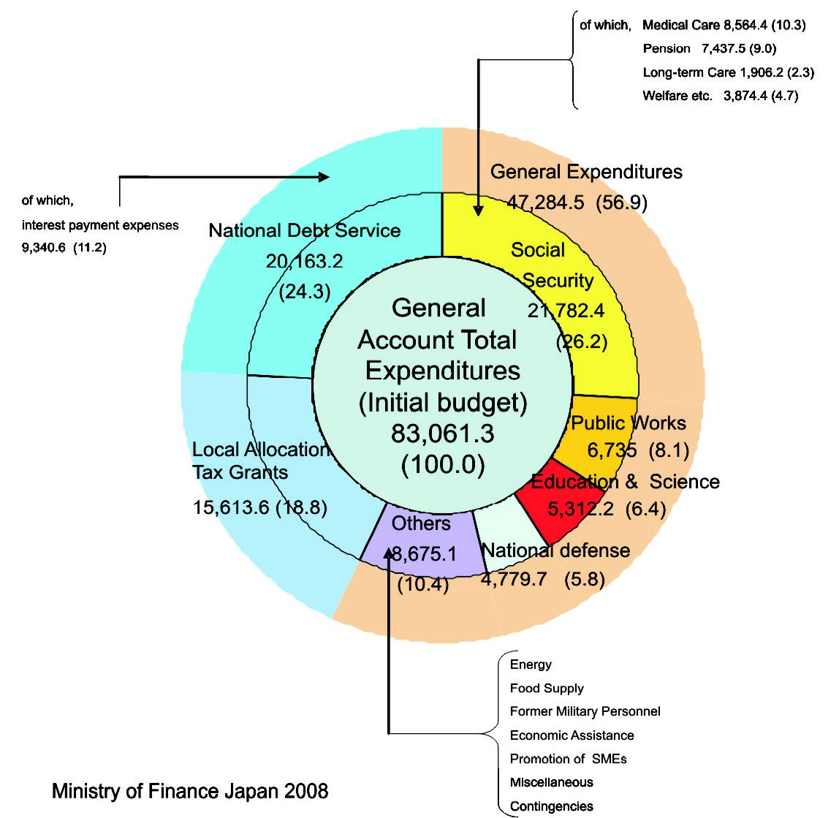

Figure 1. General account expenditures for FY2008 (Unit: billion yen, %)

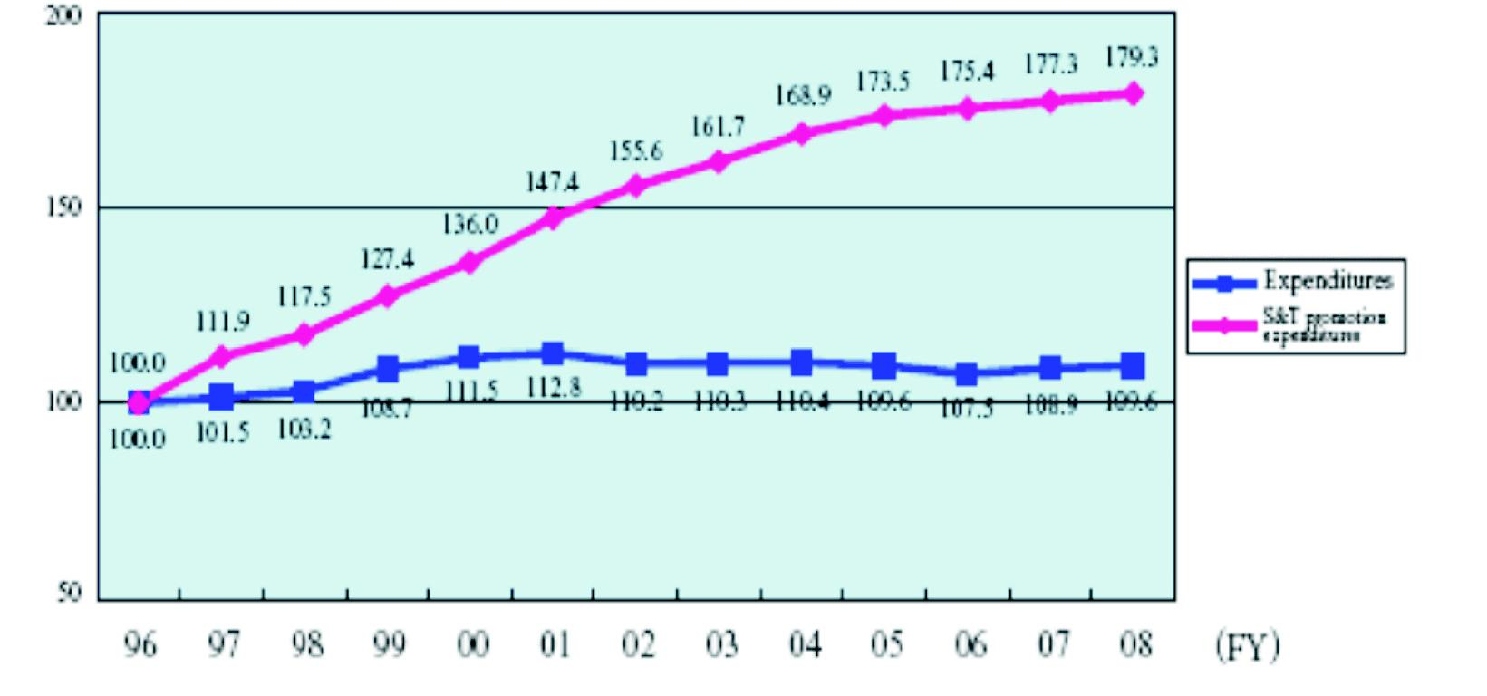
Note: Changes in indexes of science and technology expenditures and general expenditures (100 for FY 1996). Ministry of Finance Japan 2008

Figure 2. Comparison of science and technology expenditures with general expenditures

by us but to us. The second question I would like to ask, are we really committed to get access to all of these technologies, to pursue original research, dis- tinctive and useful for life science?. The situation is very critical in our country, as I already stated, modern biotechnology is evolving so fast, and today many high schools in developed countries, are setting biotech- nology labs in order to offer to the students the oppor- tunity to perform the most current bioscience experi- mentation, including bacterial transformation, manipu- lation and engineering bacterial plasmids, proteomics, and spectrophotometric analysis, thus preparing the
students to engage in a global society with real-world
science application. To my knowledge, in Colombia some high schools have already introduced gene amplification (PCR) and electrophoresis as a compo- nent of the daily science education, when many life science programs at universities have not incorporated these basic facilities for molecular biology, what can we expect in the next level of cell biology, confocal microscopy and fluorescent activated cell sorting, FACS; or in vivo cell imaging, included two-photon and multiphoton microscopy?. Finally, I would like to add something to all of these reflections, willing, coopera- tion, integration and commitment to common goals
seems to be key drivers of progress.

REFERENCIAS

Bhalerao KD. Synthetic gene networks: the next wave in biotechnology? Trends in biotechnology 2009;

Casierra-Posada y Gonzalez - Cambio Circadino de PH en la Savia de Fique
27:368-374.

DePalma A. “Twenty-Five Years of Biotech Trends”, Genetic Engineering News (Mary Ann Liebert) 2005;
25 (14): 1, 14–23.

Taylor MR, Cayford J. 2003. RESOURCES FOR THE FUTURE REPORT (RFF). American Patent Policy, Biotechnology, and African Agriculture: The Case for Policy Change.

Johnson IS. Human insulin from recombinant DNA
technology. Science (New York, N.Y) 1983; 219:632-
637.

Eschbach JW, Egrie JC, Downing MR, Browne JK, Adamson JW. Correction of the anemia of end-stage renal disease with recombinant human erythropoietin. Results of a combined phase I and II clinical trial. The New England journal of medicine 1987; 316:73-78.

Lin FK, Suggs S, Lin CH, Browne JK, Smalling R, Egrie JC, Chen KK, Fox GM, Martin F, Stabinsky Z, et al. Cloning and expression of the human erythro- poietin gene. Proceedings of the National Academy of Sciences of the United States of America 1985;
82:7580-7584.
Nagata S, Tsuchiya M, Asano S, Kaziro Y, Yamazaki T, Yamamoto O, Hirata Y, Kubota N, Oheda M, Nomura H, et al. Molecular cloning and expression of cDNA for human granulocyte colony-stimulating factor. Nature
1986; 319:415-418.

Souza LM, Boone TC, Gabrilove J, Lai PH, Zsebo KM, Murdock DC, Chazin VR, Bruszewski J, Lu H, Chen KK, et al.. Recombinant human granulocyte colony- stimulating factor: effects on normal and leukemic my- eloid cells. Science (New York, N.Y ) 1986; 232:61-65.

Gotherstrom G, Bengtsson BA, Bosaeus I, Johannsson G, Svensson J. Ten-year GH replacement increases bone mineral density in hypopituitary pa- tients with adult onset GH deficiency. European jour- nal of endocrinology / European Federation of Endo- crine Societies 2007; 156:55-64.

Nagata S, Taira H, Hall A, Johnsrud L, Streuli M, Ecsodi J, Boll W, Cantell K, Weissmann C.. Synthesis in E. coli of a polypeptide with human leukocyte interferon activity. Nature 1980; 284:316-320.

Takaoka A, Hayakawa S, Yanai H, Stoiber D, Negishi H, Kikuchi H, Sasaki S, Imai K, Shibue T, Honda K, Taniguchi T. Integration of interferon-alpha/beta signal- ling to p53 responses in tumour suppression and an- tiviral defence. Nature 2003; 424:516-523.

Druker BJ, Lydon NB. Lessons learned from the development of an abl tyrosine kinase inhibitor for chronic myelogenous leukemia. The Journal of clini- cal investigation 2000; 105:3-7.

Deininger MW, Druker BJ. Specific targeted therapy of chronic myelogenous leukemia with imatinib. Phar- macological reviews 2003; 55:401-423.

Sordella R, Bell D W, Haber DA, Settleman J. Gefitinib-sensitizing EGFR mutations in lung cancer activate anti-apoptotic pathways. Science (New York, N.Y) 2004; 305:1163-1167.

Li Z, Xu M, Xing S, Ho WT, Ishii T, Li Q, Fu X, Zhao ZJ.. Erlotinib effectively inhibits JAK2V617F activity and polycythemia vera cell growth. The Journal of biological chemistry 2007; 282:3428-3432.

Rini BI. Vascular endothelial growth factor-targeted therapy in renal cell carcinoma: current status and future directions. Clin Cancer Res 2007; 13:1098-
1106.

Bange J, Zwick E, Ullrich A. Molecular targets for breast cancer therapy and prevention. Nature medi- cine 2001; 7:548-552.
Hudis CA. Trastuzumab—mechanism of action and use in clinical practice. The New England journal of medi- cine 2007; 357:39-51.

Maloney DG, Grillo-Lopez AJ, White CA, Bodkin D, Schilder RJ, Neidhart JA, Janakiraman N, Foon KA, Liles TM, Dallaire BK, Wey K, Royston I, Davis T, Levy R.. IDEC-C2B8 (Rituximab) anti-CD20 monoclonal an- tibody therapy in patients with relapsed low-grade non- Hodgkin’s lymphoma. Blood 1997; 90:2188-2195.

Nishimoto N, Kishimoto T. Humanized antihuman IL-6 receptor antibody, tocilizumab. Handbook of experimen- tal pharmacology: 2008; 151-160.

Kishimoto T. 2009. The first International Kishimono Foundation Symposium “Immune Regulation: Present and Future” Osaka International Convention Center, Osaka Japan. May 25-27, 2009.

Ministry of Finance 2008. Current Japanese Fiscal
Conditions and Issues to be considered. http:/mof.go.jp.

Akira S. 2009. Dynamics of Immune responses. The
2nd International Symposium of WPI-IFReC. 2009. 2,12-
13. Osaka University, 3-1 Yamada-oka, Suita, Osaka, Japan.

